## Variable Speed Cooling Tower Fans

### Author

Chris Balbach, PSD Consulting

### Description

### This energy efficiency measure (EEM) replaces each existing cooling tower object present in an OpenStudio model with a CoolingTower:VariableSpeed object. While many of the existing cooling tower attributes are persisted, the following tower performance attributes will be changed: Create and apply a theoretical fan curve where fan power ratio is directly proportional to the air flow rate ratio cubed, set Minimum Air Flow Rate Ratio to 20%, set Evaporation Loss Mode to Saturated Exit, set Drift Loss Percent to 0.05, set Blowdown Calculation mode to ConcentrationRatio and set Blowdown Concentration Ratio to 3.0.

### Modeler Description

This energy efficiency measure (EEM) replaces all cooling tower objects in a model of the following types: (OS:CoolingTowerSingleSpeed or OS:CoolingTowerTwoSpeed) with a new OS:CoolingTower:VariableSpeed object. When replacing an existing tower object, the following values from the existing tower configuration will be reused: Design Inlet Air Wet Bulb Temp, Design Approach Temperature, Design Range Temperature, Design Water Flow Rate, Design Air Flow Rate, Design Fan Power, Fraction of Tower Capacity in the Free Convection Regime, Basin Heater Capacity, Basin Heater Setpoint Temperature, Basin Heater Operating Schedule, Number of Cells, Cell Control, Cell Minimum and Maximum Water Flow Rate Fractions and Sizing Factor.

A performance curve relating fan power to tower airflow rates is used. The curve assumes the fan power ratio is directly proportional to the air flow rate ratio cubed. A Minimum Air Flow Rate Ratio of 20% will be set. To model minimal but realistic water consumption, the Evaporation Loss Mode for new Tower objects will be set to “Saturated Exit” and Drift Loss Percent will be set to a value of 0.05% of the Design Water Flow. Blowdown water usage will be based on maintaining a Concentration Ratio of 3.0.

### Use Case Types

Model Articulation, Retrofit EE, New Construction EE

### Arguments

No arguments

### Initial Condition Message

### The model has {total} cooling tower objects, out of which {applicable} will be modified. Number of existing cooling towers which is (are) already configured for variable speed fan operation = {non-applicable}, and will not be modified.

### Final Condition Message

### Measure completed by replacing {single speed count} 'single speed' & {two speed count} 'two speed' cooling towers with CoolingTowerVariableSpeed objects.

### Not Applicable Messages

### IF there is no condensing loop – “Model does not contain any plantloops where Loop Type = Condenser. This measure will not alter the model.”

If existing towers are already variable speed – “This measure is not applicable. All existing cooling tower objects in the model are all already configured for variable airflow operation.”

### Warning Messages

None

### Information Messages

All the changes will be reflected in the info message.

### Error Messages

N/A

### Code Outline

* Loop through the model and populate a vector with of each type of OS component:

1. OS:CoolingTowerSingleSpeed
2. OS:CoolingTowerTwoSpeed

* Go through each array separately, since different fields need to be persisted for each object type

For OS:CoolingTowerSingleSpeed objects, retrieve existing values for:

1. Design Water Flow Rate
2. Design Air Flow Rate
3. Design Fan Power
4. Basin Heater Capacity
5. Basin Heater Setpoint Temperature,
6. Basin Heater Operating Schedule
7. Number of Cells
8. Cell Control
9. Cell Minimum Water Flow Rate Fraction
10. Cell Maximum Water Flow Rate Fraction
11. Sizing Factor
    * Remove the object and replace with a new OS:CoolingTowerVariableSpeed object
    * Configure the new object as follows (* = persist existing values)
12. Modify Name
13. Set Design Inlet Air Wet Bulb Temp = 78F
14. Set Design Approach Temperature = 7F
15. Set Design Range Temperature = 10F
16. * Set Design Water Flow Rate
17. * Set Design Air Flow Rate
18. * Set Design Fan Power
19. Create and Set Fan Power Ratio as function of Air Flow Ratio curve
20. Set Minimum Air Flow Rate Ratio = 0.20
21. Set Fraction of Tower Capacity in the Free Convection Regime = 0.125
22. * Set Basin Heater Capacity
23. * Set Basin Heater Setpoint Temperature
24. * Set Basin Heater Operating Schedule
25. Set Set Evaporation Loss Mode = “Saturated Exit”
26. Set Set Drift Loss % = .05
27. Set Blowdown Calculation Mode = “ConcentrationRatio”
28. Set BlowdownConcentrationRatio = 3
29. * Set Number of Cells
30. * Set Cell Control
31. * Set Cell Minimum Water Flow Rate Fraction
32. * Set Cell Maximum Water Flow Rate Fraction
33. * Set Sizing Factor

For OS:CoolingTowerTwoSpeed objects, retrieve existing values for:

1. Design Water Flow Rate
2. High Fan Speed Air Flow Rate
3. High Fan Speed Power
4. Basin Heater Capacity
5. Basin Heater Setpoint Temperature,
6. Basin Heater Operating Schedule
7. Number of Cells
8. Cell Control
9. Cell Minimum Water Flow Rate Fraction
10. Cell Maximum Water Flow Rate Fraction
11. Sizing Factor
    * Remove the object and replace with a new OS:CoolingTowerVariableSpeed object
    * Configure the new object as follows (* = persist existing values)
12. Modify Name
13. Set Design Inlet Air Wet Bulb Temp = 78F
14. Set Design Approach Temperature = 7F
15. Set Design Range Temperature = 10F
16. * Set Design Water Flow Rate
17. * Set Design Air Flow Rate = High Fan Speed Airflow Rate
18. * Set Design Fan Power – High Fan Speed Power
19. Create and Set Fan Power Ratio as function of Air Flow Ratio curve
20. Set Minimum Air Flow Rate Ratio = 0.20
21. Set Fraction of Tower Capacity in the Free Convection Regime = 0.125
22. * Set Basin Heater Capacity
23. * Set Basin Heater Setpoint Temperature
24. * Set Basin Heater Operating Schedule
25. Set Set Evaporation Loss Mode = “Saturated Exit”
26. Set Set Drift Loss % = .05
27. Set Blowdown Calculation Mode = “ConcentrationRatio”
28. Set BlowdownConcentrationRatio = 3
29. * Set Number of Cells
30. * Set Cell Control
31. * Set Cell Minimum Water Flow Rate Fraction
32. * Set Cell Maximum Water Flow Rate Fraction
33. * Set Sizing Factor

### Tests

**This measure applies to:**

1. 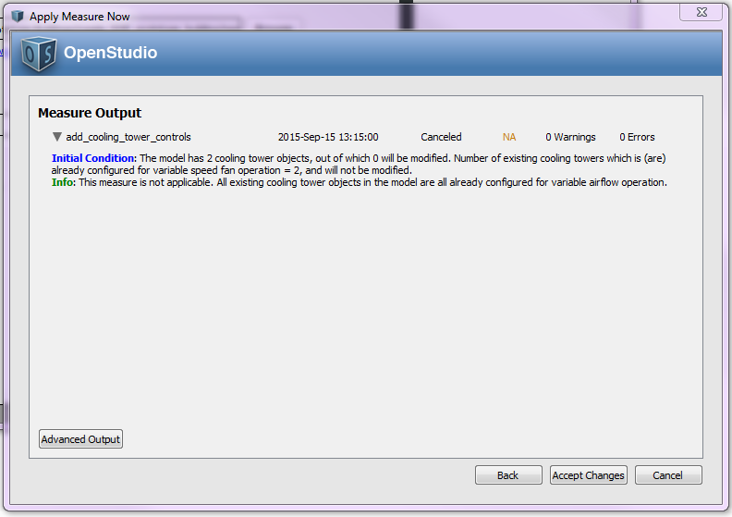Large Office
2. Hospital

**This measure does not apply to:**

1. 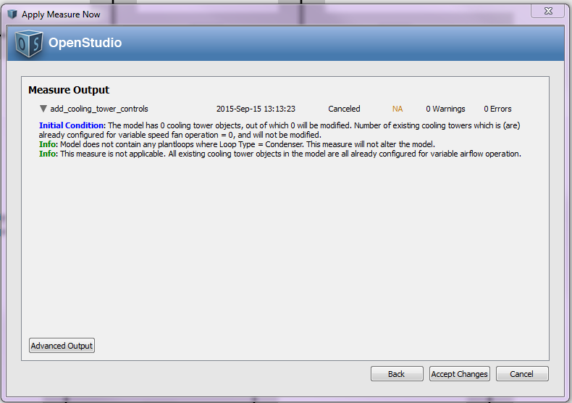Large Hotel
2. Secondary School (Has Air Cooled Chiller)

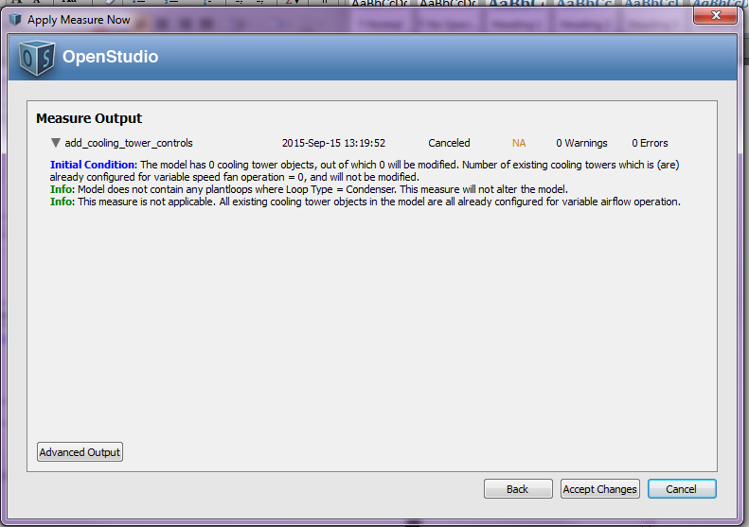

1. Primary School

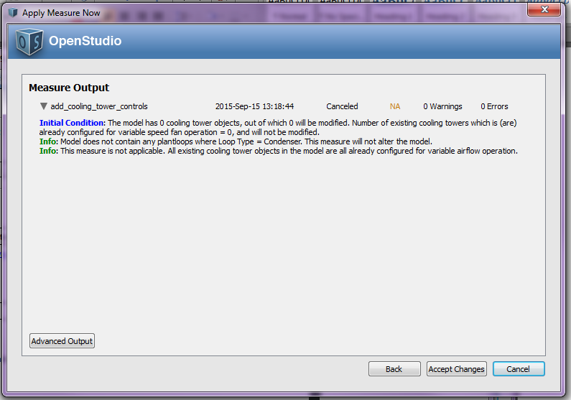

1. Outpatient Healthcare
2. Warehouse
3. Midrise Apartment
4. Small Office

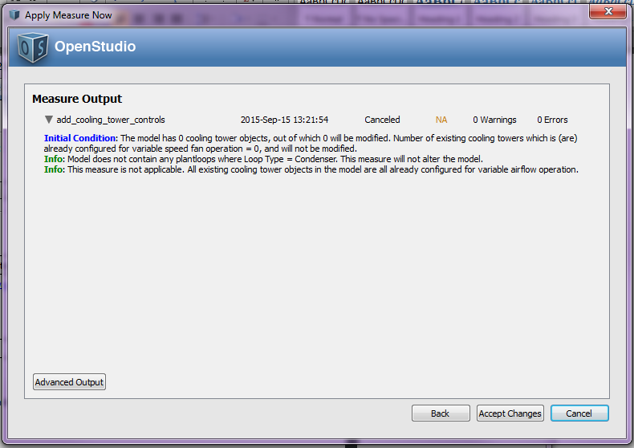

1. Medium Office

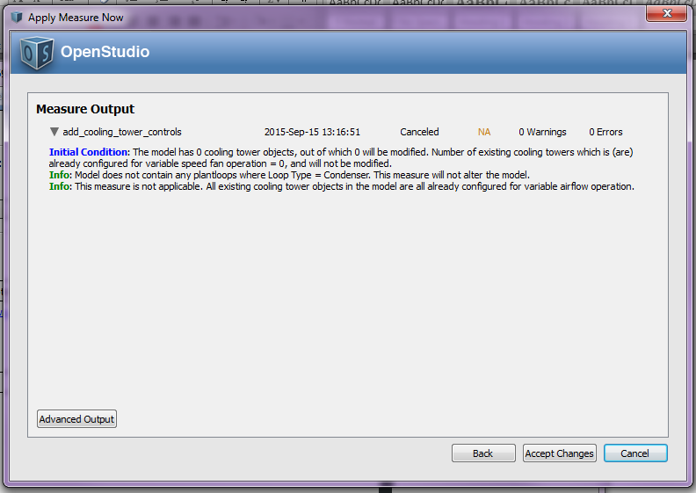

1. Stand-Alone Retail
2. Strip Mall
3. Supermarket
4. Quick Service Restaurant
5. Full Service Restaurant
6. Small Hotel

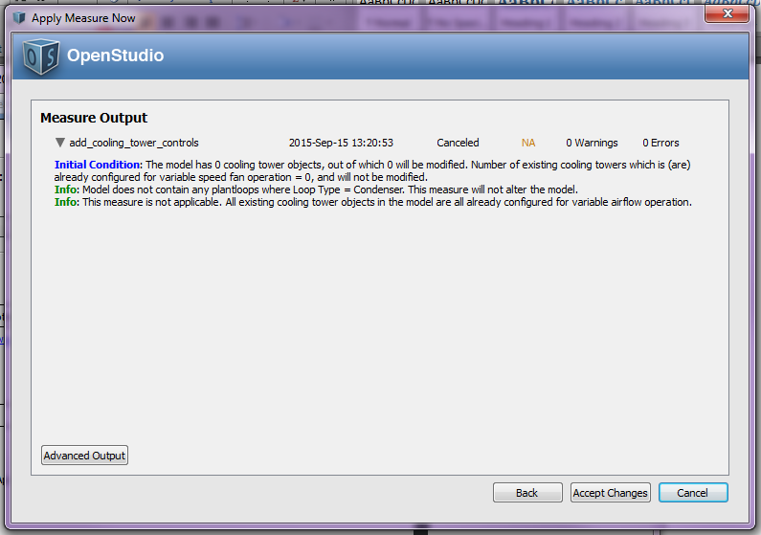

**Test results:**

Run the simulation using prototype .osm files, examine the results, cut and paste some before/after screenshots/evidence that makes you think that the measure is working correctly, including generating messages.